**Academicyear-2020-21**

**CourseName:DatabaseManagementSystems**

DBMS: ASSIGNMENT 2

TITLE: ONLINE NEWSSTANDS

**ONLINE NEWSSTANDS**

**Github link:**

**https://github.com/Ravipudisravya/DBMS-PROJECT_ONLINENEWSSTANDS**

**SOFTWARE USED:**

Java Eclipse, Oracle 11g Database, Java SE version 7, SQL*Plus.

**Java AWT:**

**Java AWT** (Abstract Window Toolkit) is  an API to develop GUI or window-based applications in java.

Java AWT components are platform-dependent i.e. components are displayed according to the view of operating system. AWT is heavyweight i.e. its components are using the resources of OS.

The java.awt package provides classes for AWT API such as TextField, Label, TextArea, Jbutton, CheckBox, Choice, List etc.

**Java Swing**

**Java Swing** is a part of Java Foundation Classes (JFC) that is used to create window-based applications. It is built on the top of AWT (Abstract Windowing Toolkit) API and entirely written in java.

Unlike AWT, Java Swing provides platform-independent and lightweight components.

The javax.swing package provides classes for java swing API such as JButton, JTextField, JTextArea, JRadioButton, JCheckbox, JMenu, JColorChooser etc.

**SQL:**

Structure Query Language(SQL) is a database query language used for storing and managing data in Relational DBMS. SQL was the first commercial language introduced for E.F Codd's **Relational** model of database. Today almost all RDBMS (MySql, Oracle, Infomix, Sybase, MS Access) use **SQL** as the standard database query language. SQL is used to perform all types of data operations in RDBMS.

**Java-SQL Connectivity using JDBC:**

**Java Database Connectivity** (**JDBC**) is an application programming interface (API) for the programming language Java, which defines how a client may access a database. It is a Java-based data access technology used for Java database connectivity. It is part of the Java Standard Edition platform, from Oracle Corporation. It provides methods to query and update data in a database and is oriented towards relational databases.

The connection to the database can be performed using Java programming (JDBC API) as:

**class** MysqlCon{

**public** **static** **void** main(String args[]){

**try**{

Class.*forName*("oracle.jdbc.driver.OracleDriver");

Connection con=DriverManager.*getConnection*("jdbc:oracle:thin:@DESKTOP-VUQHR63:1521:xe","system","sravya");

Statement stmt=con.createStatement();

con.close();

}**catch**(Exception e){ System.***out***.println(e);}

}

}

Thus, the connection from Java to Oracle database is performed and therefore, can be used for updating tables in the database directly.

**IMPLEMENTATION:**

package info;

import javax.swing.*;

import java.awt.event.*;

import java.sql.*;

import java.awt.Font;

import java.awt.Color;

public class onlineNewsstands implements ActionListener {

JFrame f= new JFrame("Example");

JLabel l1,l2, l3, l4, l5, l6,l,ll1,ll2, ll3, ll4, ll5, ll6,ll, li1,li2, li3, li4, li5, li6,li;

JTextField tf1,tf2,tf3,tf4,tf5,tf6,tff1,tff2,tff3,tff4,tff5,tff6,tif1,tif2,tif3,tif4,tif5,tif6;

JButton bu,bu1,bu2,bu3,bu4,bu5,bu6,bu7,bu8,bu9,bu10,bu11,bu12,bu13,bu14,bu15,bu16,bu17;

JLabel lb1,lb2, lb3, lb4, lb5, lb6,lb,lb7,la1,la2, la3, la4, la5, la6,la,la7,lc1,lc2, lc3, lc4, lc5, lc6,lc,lc7;

JTextField t1,t2,t3,t4,t5,t6,ta1,ta2,ta3,ta4,ta5,ta6,tc1,tc2,tc3,tc4,tc5,tc6;

JLabel ld1,ld2, ld3, ld4,ld,le1,le2, le3, le4,le,lh1,lh2, lh3, lh4,lh;

JTextField td1,td2,td3,td4,te1,te2,te3,te4,th1,th2,th3,th4;

JLabel lj1,lj2, lj3, lj4,lj,lk1,lk2, lk3, lk4,lk,lm1,lm2,lm3,lm4,lm,ln1,ln2, ln3, ln, lo1,lo2, lo3,lo;

JTextField tj1,tj2,tj3,tj4,tk1,tk2,tk3,tk4,tm1,tm2,tm3,tm4,tn1,tn2,tn3,to1,to2,to3;

JLabel lu1,lu2, lu3,lu,lp1,lp2,lp,lq1,lq2,lq,lr1,lr2,lr;

JTextField tu1,tu2,tu3,tp1,tp2, tq1,tq2,tr1,tr2;

Connection con;Statement stmt;

JFrame p=new JFrame("user insert");

JFrame q=new JFrame("user modify");

JFrame r=new JFrame("user delete");

JFrame s=new JFrame("news insert");

JFrame t=new JFrame("news modify");

JFrame p1=new JFrame("news delete");

JFrame q1=new JFrame("insert advertisement");

JFrame r1=new JFrame("modify advertisement");

JFrame s1=new JFrame("delete advertisement");

JFrame p2=new JFrame("insert publisher");

JFrame q2=new JFrame("modify publisher");

JFrame r2=new JFrame("delete publisher");

JFrame p3=new JFrame("insert Read");

JFrame q3=new JFrame("modify Read");

JFrame r3=new JFrame("delete Read");

JFrame p4=new JFrame("insert published");

JFrame q4=new JFrame("modify published");

JFrame r4=new JFrame("delete published");

JMenuBar mb=new JMenuBar();

JMenu menu=new JMenu("USER");

JMenu menu1=new JMenu("NEWS");

JMenu menu2=new JMenu("ADVERTISEMNETS");

JMenuItem i1=new JMenuItem("insert user");

JMenuItem i2=new JMenuItem("modify user");

JMenuItem i3=new JMenuItem("delete user");

JMenuItem i4=new JMenuItem("insert news");

JMenuItem i5=new JMenuItem("modify news");

JMenuItem i6=new JMenuItem("delete news");

JMenuItem i7=new JMenuItem("insert advertisement");

JMenuItem i8=new JMenuItem("modify advertisement");

JMenuItem i9=new JMenuItem("delete advertisement");

JMenu menu3=new JMenu("PUBLISHER");

JMenuItem a=new JMenuItem("insert publisher");

JMenuItem b=new JMenuItem("modify publisher");

JMenuItem c=new JMenuItem("delete publisher");

JMenu menu4=new JMenu("READ");

JMenuItem a1=new JMenuItem("insert Read");

JMenuItem b1=new JMenuItem("modify Read");

JMenuItem c1=new JMenuItem("delete Read");

JMenu menu5=new JMenu("PUBLISHED");

JMenuItem a2=new JMenuItem("insert published");

JMenuItem b2=new JMenuItem("modify published");

JMenuItem c2=new JMenuItem("delete published");

onlineNewsstands(){

l1=new JLabel(" ONLINE NEWSSTANDS ");

l1.setFont(new Font("Tahoma", Font.PLAIN, 30));

l1.setBounds(50,100,419,76);

menu.setForeground(Color.BLACK);

menu.add(i1);

menu.add(i2);

menu.add(i3);

mb.add(menu);

menu1.setForeground(Color.BLACK);

menu1.add(i4);

menu1.add(i5);

menu1.add(i6);

mb.add(menu1);

menu2.setForeground(Color.BLACK);

menu2.add(i7);

menu2.add(i8);

menu2.add(i9);

mb.add(menu2);

menu3.setForeground(Color.BLACK);

menu3.add(a);

menu3.add(b);

menu3.add(c);

mb.add(menu3);

menu4.setForeground(Color.BLACK);

menu4.add(a1);

menu4.add(b1);

menu4.add(c1);

mb.add(menu4);

menu5.setForeground(Color.BLACK);

menu5.add(a2);

menu5.add(b2);

menu5.add(c2);

mb.add(menu5);

f.getContentPane().setForeground(Color.GRAY);

f.setDefaultCloseOperation(JFrame.EXIT_ON_CLOSE);

q.setDefaultCloseOperation(JFrame.EXIT_ON_CLOSE);

r.setDefaultCloseOperation(JFrame.EXIT_ON_CLOSE);

f.getContentPane().add(l1);

f.setJMenuBar(mb);

f.setSize(700,486);

f.getContentPane().setLayout(null);

f.setVisible(true);

p.setSize(700,555);

p.setDefaultCloseOperation(JFrame.EXIT_ON_CLOSE);

q.setSize(700,700);

r.setSize(700,700);

s.setSize(700,700);

t.setSize(700,700);

p1.setSize(700,700);

q1.setSize(700,700);

r1.setSize(700,700);

s1.setSize(700,700);

p2.setSize(700,700);

q2.setSize(700,700);

r2.setSize(700,700);

p3.setSize(700,700);

q3.setSize(700,700);

r3.setSize(700,700);

p4.setSize(700,700);

q4.setSize(700,700);

r4.setSize(700,700);

bu=new JButton("INSERT");

bu.setFont(new Font("Tahoma", Font.PLAIN, 14));

bu.setBackground(Color.WHITE);

l=new JLabel(" USER INSERTION");

l.setFont(new Font("Tahoma", Font.PLAIN, 18));

l.setVerticalAlignment(SwingConstants.TOP);

l.setBounds(100, 30, 400, 30);

l2 = new JLabel("ID:");

l2.setFont(new Font("Tahoma", Font.PLAIN, 14));

l3 = new JLabel("Name:");

l3.setFont(new Font("Tahoma", Font.PLAIN, 14));

l4 = new JLabel("Email:");

l4.setFont(new Font("Tahoma", Font.PLAIN, 14));

l5 = new JLabel("Password:");

l5.setFont(new Font("Tahoma", Font.PLAIN, 14));

l6 = new JLabel("Address:");

l6.setFont(new Font("Tahoma", Font.PLAIN, 14));

tf1 = new JTextField();

tf2 = new JTextField();

tf3 = new JTextField();

tf4 = new JTextField();

tf5 = new JTextField();

l2.setBounds(80, 70, 200, 30);

l3.setBounds(80, 110, 200, 30);

l4.setBounds(80, 150, 200, 30);

l5.setBounds(80, 190, 200, 30);

l6.setBounds(80, 230, 200, 30);

tf1.setBounds(300, 70, 200, 30);

tf2.setBounds(300, 110, 200, 30);

tf3.setBounds(300, 150, 200, 30);

tf4.setBounds(300, 190, 200, 30);

tf5.setBounds(300, 230, 200, 30);

bu.setBounds(170, 350, 100, 30);

p.getContentPane().add(tf1);p.getContentPane().add(tf2);p.getContentPane().add(tf3);p.getContentPane().add(tf4);p.getContentPane().add(tf5);p.getContentPane().add(bu);p.getContentPane().add(l2);p.getContentPane().add(l3);p.getContentPane().add(l4);p.getContentPane().add(l5);p.getContentPane().add(l6);p.getContentPane().add(l);

bu.addActionListener(this);

bu1=new JButton("MODIFY");

bu1.setFont(new Font("Tahoma", Font.PLAIN, 14));

bu1.setBackground(Color.WHITE);

ll=new JLabel(" USER MODIFICATION");

ll.setFont(new Font("Tahoma", Font.PLAIN, 16));

ll.setVerticalAlignment(SwingConstants.TOP);

ll.setBounds(100, 30, 400, 30);

ll2 = new JLabel("ID:");

ll2.setFont(new Font("Tahoma", Font.PLAIN, 14));

ll3 = new JLabel("Name:");

ll3.setFont(new Font("Tahoma", Font.PLAIN, 14));

ll4 = new JLabel("Email:");

ll4.setFont(new Font("Tahoma", Font.PLAIN, 14));

ll5 = new JLabel("Password:");

ll5.setFont(new Font("Tahoma", Font.PLAIN, 14));

ll6 = new JLabel("Address:");

ll6.setFont(new Font("Tahoma", Font.PLAIN, 14));

tff1 = new JTextField();

tff2 = new JTextField();

tff3 = new JTextField();

tff4 = new JTextField();

tff5 = new JTextField();

ll2.setBounds(80, 70, 200, 30);

ll3.setBounds(80, 110, 200, 30);

ll4.setBounds(80, 150, 200, 30);

ll5.setBounds(80, 190, 200, 30);

ll6.setBounds(80, 230, 200, 30);

tff1.setBounds(300, 70, 200, 30);

tff2.setBounds(300, 110, 200, 30);

tff3.setBounds(300, 150, 200, 30);

tff4.setBounds(300, 190, 200, 30);

tff5.setBounds(300, 230, 200, 30);

bu1.setBounds(170, 350, 100, 30);

q.getContentPane().add(tff1);q.getContentPane().add(tff2);q.getContentPane().add(tff3);q.getContentPane().add(tff4);q.getContentPane().add(tff5);q.getContentPane().add(bu1);q.getContentPane().add(ll2);q.getContentPane().add(ll3);q.getContentPane().add(ll4);q.getContentPane().add(ll5);q.getContentPane().add(ll6);q.getContentPane().add(ll);

bu1.addActionListener(this);

bu2=new JButton("DELETE");

bu2.setFont(new Font("Tahoma", Font.PLAIN, 14));

bu2.setBackground(Color.WHITE);

li=new JLabel(" USER DELETION");

li.setFont(new Font("Tahoma", Font.PLAIN, 18));

li.setVerticalAlignment(SwingConstants.TOP);

li.setBounds(100, 30, 400, 30);

li2 = new JLabel("ID:");

li2.setFont(new Font("Tahoma", Font.PLAIN, 14));

li3 = new JLabel("Name:");

li3.setFont(new Font("Tahoma", Font.PLAIN, 14));

li4 = new JLabel("Email:");

li4.setFont(new Font("Tahoma", Font.PLAIN, 14));

li5 = new JLabel("Password:");

li5.setFont(new Font("Tahoma", Font.PLAIN, 14));

li6 = new JLabel("Address:");

li6.setFont(new Font("Tahoma", Font.PLAIN, 14));

tif1 = new JTextField();

tif2 = new JTextField();

tif3 = new JTextField();

tif4 = new JTextField();

tif5 = new JTextField();

li2.setBounds(80, 70, 200, 30);

li3.setBounds(80, 110, 200, 30);

li4.setBounds(80, 150, 200, 30);

li5.setBounds(80, 190, 200, 30);

li6.setBounds(80, 230, 200, 30);

tif1.setBounds(300, 70, 200, 30);

tif2.setBounds(300, 110, 200, 30);

tif3.setBounds(300, 150, 200, 30);

tif4.setBounds(300, 190, 200, 30);

tif5.setBounds(300, 230, 200, 30);

bu2.setBounds(170, 350, 100, 30);

r.getContentPane().add(tif1);r.getContentPane().add(tif2);r.getContentPane().add(tif3);r.getContentPane().add(tif4);r.getContentPane().add(tif5);r.getContentPane().add(bu2);r.getContentPane().add(li2);r.getContentPane().add(li3);r.getContentPane().add(li4);r.getContentPane().add(li5);r.getContentPane().add(li6);r.getContentPane().add(li);

bu2.addActionListener(this);

bu3=new JButton("insert");

bu3.setFont(new Font("Tahoma", Font.PLAIN, 14));

bu3.setBackground(Color.WHITE);

lb=new JLabel(" NEWS INSERTION");

lb.setFont(new Font("Tahoma", Font.PLAIN, 16));

lb.setVerticalAlignment(SwingConstants.TOP);

lb.setBounds(100, 30, 400, 30);

lb2 = new JLabel("ID:");

lb2.setFont(new Font("Tahoma", Font.PLAIN, 14));

lb3 = new JLabel("TYPE:");

lb3.setFont(new Font("Tahoma", Font.PLAIN, 14));

lb4 = new JLabel("TITLE:");

lb4.setFont(new Font("Tahoma", Font.PLAIN, 14));

lb5 = new JLabel("DESCRIPTION:");

lb5.setFont(new Font("Tahoma", Font.PLAIN, 14));

lb6 = new JLabel(" DATE:");

lb6.setFont(new Font("Tahoma", Font.PLAIN, 14));

lb7= new JLabel(" PUBLISHER NAME:");

lb7.setFont(new Font("Tahoma", Font.PLAIN, 14));

t1 = new JTextField();

t2 = new JTextField();

t3 = new JTextField();

t4 = new JTextField();

t5 = new JTextField();

t6 = new JTextField();

lb2.setBounds(80, 70, 200, 30);

lb3.setBounds(80, 110, 200, 30);

lb4.setBounds(80, 150, 200, 30);

lb5.setBounds(80, 190, 200, 30);

lb6.setBounds(80, 230, 200, 30);

lb7.setBounds(80, 270, 200, 30);

t1.setBounds(300, 70, 200, 30);

t2.setBounds(300, 110, 200, 30);

t3.setBounds(300, 150, 200, 30);

t4.setBounds(300, 190, 200, 30);

t5.setBounds(300, 230, 200, 30);

t6.setBounds(300, 270, 200, 30);

bu3.setBounds(170, 350, 100, 30);

s.getContentPane().add(t1);s.getContentPane().add(t2);s.getContentPane().add(t3);s.getContentPane().add(t4);s.getContentPane().add(t5);s.getContentPane().add(t6);s.getContentPane().add(bu3);s.getContentPane().add(lb2);s.getContentPane().add(lb3);s.getContentPane().add(lb4);s.getContentPane().add(lb5);s.getContentPane().add(lb6);s.getContentPane().add(lb7);s.getContentPane().add(lb);

bu4=new JButton("modify");

bu4.setFont(new Font("Tahoma", Font.PLAIN, 14));

bu4.setBackground(Color.WHITE);

la=new JLabel(" NEWS MODIFICATION");

la.setFont(new Font("Tahoma", Font.PLAIN, 16));

la.setVerticalAlignment(SwingConstants.TOP);

la.setBounds(100, 30, 400, 30);

la2 = new JLabel("ID:");

la2.setFont(new Font("Tahoma", Font.PLAIN, 14));

la3 = new JLabel("TYPE:");

la3.setFont(new Font("Tahoma", Font.PLAIN, 14));

la4 = new JLabel("TITLE:");

la4.setFont(new Font("Tahoma", Font.PLAIN, 14));

la5 = new JLabel("DESCRIPTION:");

la5.setFont(new Font("Tahoma", Font.PLAIN, 14));

la6 = new JLabel(" DATE:");

la6.setFont(new Font("Tahoma", Font.PLAIN, 14));

la7= new JLabel(" PUBLISHER NAME:");

la7.setFont(new Font("Tahoma", Font.PLAIN, 14));

ta1 = new JTextField();

ta2 = new JTextField();

ta3 = new JTextField();

ta4 = new JTextField();

ta5 = new JTextField();

ta6 = new JTextField();

la2.setBounds(80, 70, 200, 30);

la3.setBounds(80, 110, 200, 30);

la4.setBounds(80, 150, 200, 30);

la5.setBounds(80, 190, 200, 30);

la6.setBounds(80, 230, 200, 30);

la7.setBounds(80, 270, 200, 30);

ta1.setBounds(300, 70, 200, 30);

ta2.setBounds(300, 110, 200, 30);

ta3.setBounds(300, 150, 200, 30);

ta4.setBounds(300, 190, 200, 30);

ta5.setBounds(300, 230, 200, 30);

ta6.setBounds(300, 270, 200, 30);

bu4.setBounds(170, 350, 100, 30);

t.getContentPane().add(ta1);t.getContentPane().add(ta2);t.getContentPane().add(ta3);t.getContentPane().add(ta4);t.getContentPane().add(ta5);t.getContentPane().add(ta6);t.getContentPane().add(bu4);t.getContentPane().add(la2);t.getContentPane().add(la3);t.getContentPane().add(la4);t.getContentPane().add(la5);t.getContentPane().add(la6);t.getContentPane().add(la7);t.getContentPane().add(la);

bu5=new JButton("delete");

bu5.setFont(new Font("Tahoma", Font.PLAIN, 14));

bu5.setBackground(Color.WHITE);

lc=new JLabel(" NEWS DELETION");

lc.setFont(new Font("Tahoma", Font.PLAIN, 16));

lc.setVerticalAlignment(SwingConstants.TOP);

lc.setBounds(100, 30, 400, 30);

lc2 = new JLabel("ID:");

lc2.setFont(new Font("Tahoma", Font.PLAIN, 14));

lc3 = new JLabel("TYPE:");

lc3.setFont(new Font("Tahoma", Font.PLAIN, 14));

lc4 = new JLabel("TITLE:");

lc4.setFont(new Font("Tahoma", Font.PLAIN, 14));

lc5 = new JLabel("DESCRIPTION:");

lc5.setFont(new Font("Tahoma", Font.PLAIN, 14));

lc6 = new JLabel(" DATE:");

lc6.setFont(new Font("Tahoma", Font.PLAIN, 14));

lc7= new JLabel(" PUBLISHER NAME:");

lc7.setFont(new Font("Tahoma", Font.PLAIN, 14));

tc1 = new JTextField();

tc2 = new JTextField();

tc3 = new JTextField();

tc4 = new JTextField();

tc5 = new JTextField();

tc6 = new JTextField();

lc2.setBounds(80, 70, 200, 30);

lc3.setBounds(80, 110, 200, 30);

lc4.setBounds(80, 150, 200, 30);

lc5.setBounds(80, 190, 200, 30);

lc6.setBounds(80, 230, 200, 30);

lc7.setBounds(80, 270, 200, 30);

tc1.setBounds(300, 70, 200, 30);

tc2.setBounds(300, 110, 200, 30);

tc3.setBounds(300, 150, 200, 30);

tc4.setBounds(300, 190, 200, 30);

tc5.setBounds(300, 230, 200, 30);

tc6.setBounds(300, 270, 200, 30);

bu5.setBounds(170, 350, 100, 30);

p1.getContentPane().add(tc1);p1.getContentPane().add(tc2);p1.getContentPane().add(tc3);p1.getContentPane().add(tc4);p1.getContentPane().add(tc5);p1.getContentPane().add(tc6);p1.getContentPane().add(bu5);p1.getContentPane().add(lc2);p1.getContentPane().add(lc3);p1.getContentPane().add(lc4);p1.getContentPane().add(la5);p1.getContentPane().add(lc6);p1.getContentPane().add(lc7);p1.getContentPane().add(lc);

bu6=new JButton("insert");

bu6.setFont(new Font("Tahoma", Font.PLAIN, 14));

bu6.setBackground(Color.WHITE);

ld=new JLabel(" ADVERTISEMENTS INSERTION");

ld.setFont(new Font("Tahoma", Font.PLAIN, 16));

ld.setVerticalAlignment(SwingConstants.TOP);

ld.setBounds(100, 30, 400, 30);

ld1 = new JLabel("ID:");

ld1.setFont(new Font("Tahoma", Font.PLAIN, 14));

ld2 = new JLabel("TYPE:");

ld2.setFont(new Font("Tahoma", Font.PLAIN, 14));

ld3 = new JLabel("TITLE:");

ld3.setFont(new Font("Tahoma", Font.PLAIN, 14));

ld4 = new JLabel("DATE:");

ld4.setFont(new Font("Tahoma", Font.PLAIN, 14));

td1 = new JTextField();

td2 = new JTextField();

td3 = new JTextField();

td4 = new JTextField();

ld1.setBounds(80, 70, 200, 30);

ld2.setBounds(80, 110, 200, 30);

ld3.setBounds(80, 150, 200, 30);

ld4.setBounds(80, 190, 200, 30);

td1.setBounds(300, 70, 200, 30);

td2.setBounds(300, 110, 200, 30);

td3.setBounds(300, 150, 200, 30);

td4.setBounds(300, 190, 200, 30);

bu6.setBounds(170, 350, 100, 30);

q1.getContentPane().add(td1);q1.getContentPane().add(td2);q1.getContentPane().add(td3);q1.getContentPane().add(td4);q1.getContentPane().add(bu6);q1.getContentPane().add(ld1);q1.getContentPane().add(ld2);q1.getContentPane().add(ld3);q1.getContentPane().add(ld4);q1.getContentPane().add(ld);

bu7=new JButton("modify");

bu7.setFont(new Font("Tahoma", Font.PLAIN, 14));

bu7.setBackground(Color.WHITE);

le=new JLabel(" ADVERTISEMENT MODIFICATION");

le.setFont(new Font("Tahoma", Font.PLAIN, 16));

le.setVerticalAlignment(SwingConstants.TOP);

le.setBounds(100, 30, 400, 30);

le1 = new JLabel("Id:");

le1.setFont(new Font("Tahoma", Font.PLAIN, 14));

le2 = new JLabel("TYPE:");

le2.setFont(new Font("Tahoma", Font.PLAIN, 14));

le3 = new JLabel("TITLE:");

le3.setFont(new Font("Tahoma", Font.PLAIN, 14));

le4 = new JLabel("DATE:");

le4.setFont(new Font("Tahoma", Font.PLAIN, 14));

te1 = new JTextField();

te2 = new JTextField();

te3 = new JTextField();

te4 = new JTextField();

le1.setBounds(80, 70, 200, 30);

le2.setBounds(80, 110, 200, 30);

le3.setBounds(80, 150, 200, 30);

le4.setBounds(80, 190, 200, 30);

te1.setBounds(300, 70, 200, 30);

te2.setBounds(300, 110, 200, 30);

te3.setBounds(300, 150, 200, 30);

te4.setBounds(300, 190, 200, 30);

bu7.setBounds(170, 350, 100, 30);

r1.getContentPane().add(te1);r1.getContentPane().add(te2);r1.getContentPane().add(te3);r1.getContentPane().add(te4);r1.getContentPane().add(bu7);r1.getContentPane().add(le1);r1.getContentPane().add(le2);r1.getContentPane().add(le3);r1.getContentPane().add(le4);r1.getContentPane().add(le);

bu8=new JButton("delete");

bu8.setFont(new Font("Tahoma", Font.PLAIN, 14));

bu8.setBackground(Color.WHITE);

lh=new JLabel(" ADVERTISEMENT DELETION");

lh.setFont(new Font("Tahoma", Font.PLAIN, 16));

lh.setVerticalAlignment(SwingConstants.TOP);

lh.setBounds(100, 30, 400, 30);

lh1 = new JLabel("Id:");

lh1.setFont(new Font("Tahoma", Font.PLAIN, 14));

lh2 = new JLabel("TYPE:");

lh2.setFont(new Font("Tahoma", Font.PLAIN, 14));

lh3 = new JLabel("TITLE:");

lh3.setFont(new Font("Tahoma", Font.PLAIN, 14));

lh4 = new JLabel("DATE:");

lh4.setFont(new Font("Tahoma", Font.PLAIN, 14));

th1 = new JTextField();

th2 = new JTextField();

th3 = new JTextField();

th4 = new JTextField();

lh1.setBounds(80, 70, 200, 30);

lh2.setBounds(80, 110, 200, 30);

lh3.setBounds(80, 150, 200, 30);

lh4.setBounds(80, 190, 200, 30);

th1.setBounds(300, 70, 200, 30);

th2.setBounds(300, 110, 200, 30);

th3.setBounds(300, 150, 200, 30);

th4.setBounds(300, 190, 200, 30);

bu8.setBounds(170, 350, 100, 30);

s1.getContentPane().add(th1);s1.getContentPane().add(th2);s1.getContentPane().add(th3);s1.getContentPane().add(th4);s1.getContentPane().add(bu8);s1.getContentPane().add(lh1);s1.getContentPane().add(lh2);s1.getContentPane().add(lh3);s1.getContentPane().add(lh4);s1.getContentPane().add(lh);

bu9=new JButton("insert");

bu9.setFont(new Font("Tahoma", Font.PLAIN, 14));

bu9.setBackground(Color.WHITE);

lj=new JLabel(" PUBLISHER INSERTION");

lj.setFont(new Font("Tahoma", Font.PLAIN, 16));

lj.setVerticalAlignment(SwingConstants.TOP);

lj.setBounds(100, 30, 400, 30);

lj1 = new JLabel("Id:");

lj1.setFont(new Font("Tahoma", Font.PLAIN, 14));

lj2 = new JLabel("NAME:");

lj2.setFont(new Font("Tahoma", Font.PLAIN, 14));

lj3 = new JLabel("EMAIL:");

lj3.setFont(new Font("Tahoma", Font.PLAIN, 14));

lj4 = new JLabel("DATE:");

lj4.setFont(new Font("Tahoma", Font.PLAIN, 14));

tj1 = new JTextField();

tj2 = new JTextField();

tj3 = new JTextField();

tj4 = new JTextField();

lj1.setBounds(80, 70, 200, 30);

lj2.setBounds(80, 110, 200, 30);

lj3.setBounds(80, 150, 200, 30);

lj4.setBounds(80, 190, 200, 30);

tj1.setBounds(300, 70, 200, 30);

tj2.setBounds(300, 110, 200, 30);

tj3.setBounds(300, 150, 200, 30);

tj4.setBounds(300, 190, 200, 30);

bu9.setBounds(170, 350, 100, 30);

p2.getContentPane().add(tj1);p2.getContentPane().add(tj2);p2.getContentPane().add(tj3);p2.getContentPane().add(tj4);p2.getContentPane().add(bu9);p2.getContentPane().add(lj1);p2.getContentPane().add(lj2);p2.getContentPane().add(lj3);p2.getContentPane().add(lj4);p2.getContentPane().add(lj);

bu10=new JButton("modify");

bu10.setFont(new Font("Tahoma", Font.PLAIN, 14));

bu10.setBackground(Color.WHITE);

lk=new JLabel(" PUBLISHER MODIFICATION");

lk.setFont(new Font("Tahoma", Font.PLAIN, 16));

lk.setVerticalAlignment(SwingConstants.TOP);

lk.setBounds(100, 30, 400, 30);

lk1 = new JLabel("Id:");

lk1.setFont(new Font("Tahoma", Font.PLAIN, 14));

lk2 = new JLabel("NAME:");

lk2.setFont(new Font("Tahoma", Font.PLAIN, 14));

lk3 = new JLabel("EMAIL:");

lk3.setFont(new Font("Tahoma", Font.PLAIN, 14));

lk4 = new JLabel("DATE:");

lk4.setFont(new Font("Tahoma", Font.PLAIN, 14));

tk1 = new JTextField();

tk2 = new JTextField();

tk3 = new JTextField();

tk4 = new JTextField();

lk1.setBounds(80, 70, 200, 30);

lk2.setBounds(80, 110, 200, 30);

lk3.setBounds(80, 150, 200, 30);

lk4.setBounds(80, 190, 200, 30);

tk1.setBounds(300, 70, 200, 30);

tk2.setBounds(300, 110, 200, 30);

tk3.setBounds(300, 150, 200, 30);

tk4.setBounds(300, 190, 200, 30);

bu10.setBounds(170, 350, 100, 30);

q2.getContentPane().add(tk1);q2.getContentPane().add(tk2);q2.getContentPane().add(tk3);q2.getContentPane().add(tk4);q2.getContentPane().add(bu10);q2.getContentPane().add(lk1);q2.getContentPane().add(lk2);q2.getContentPane().add(lk3);q2.getContentPane().add(lk4);q2.getContentPane().add(lk);

bu11=new JButton("delete");

bu11.setFont(new Font("Tahoma", Font.PLAIN, 14));

bu11.setBackground(Color.WHITE);

lm=new JLabel(" PUBLISHER DELETION");

lm.setFont(new Font("Tahoma", Font.PLAIN, 16));

lm.setVerticalAlignment(SwingConstants.TOP);

lm.setBounds(100, 30, 400, 30);

lm1 = new JLabel("Id:");

lm1.setFont(new Font("Tahoma", Font.PLAIN, 14));

lm2 = new JLabel("NAME:");

lm2.setFont(new Font("Tahoma", Font.PLAIN, 14));

lm3 = new JLabel("EMAIL:");

lm3.setFont(new Font("Tahoma", Font.PLAIN, 14));

lm4 = new JLabel("DATE:");

lm4.setFont(new Font("Tahoma", Font.PLAIN, 14));

tm1 = new JTextField();

tm2 = new JTextField();

tm3 = new JTextField();

tm4 = new JTextField();

lm1.setBounds(80, 70, 200, 30);

lm2.setBounds(80, 110, 200, 30);

lm3.setBounds(80, 150, 200, 30);

lm4.setBounds(80, 190, 200, 30);

tm1.setBounds(300, 70, 200, 30);

tm2.setBounds(300, 110, 200, 30);

tm3.setBounds(300, 150, 200, 30);

tm4.setBounds(300, 190, 200, 30);

bu11.setBounds(170, 350, 100, 30);

r2.getContentPane().add(tm1);r2.getContentPane().add(tm2);r2.getContentPane().add(tm3);r2.getContentPane().add(tm4);r2.getContentPane().add(bu11);r2.getContentPane().add(lm1);r2.getContentPane().add(lm2);r2.getContentPane().add(lm3);r2.getContentPane().add(lm4);r2.getContentPane().add(lm);

bu12=new JButton("insert");

bu12.setFont(new Font("Tahoma", Font.PLAIN, 14));

bu12.setBackground(Color.WHITE);

ln=new JLabel(" READ INSERTION");

ln.setFont(new Font("Tahoma", Font.PLAIN, 16));

ln.setVerticalAlignment(SwingConstants.TOP);

ln.setBounds(100, 30, 400, 30);

ln1 = new JLabel(" USER Id:");

ln1.setFont(new Font("Tahoma", Font.PLAIN, 14));

ln2 = new JLabel("NEWS ID:");

ln2.setFont(new Font("Tahoma", Font.PLAIN, 14));

ln3 = new JLabel("ADVERTISEMENT ID:");

ln3.setFont(new Font("Tahoma", Font.PLAIN, 14));

tn1 = new JTextField();

tn2 = new JTextField();

tn3 = new JTextField();

ln1.setBounds(80, 70, 200, 30);

ln2.setBounds(80, 110, 200, 30);

ln3.setBounds(80, 150, 200, 30);

tn1.setBounds(300, 70, 200, 30);

tn2.setBounds(300, 110, 200, 30);

tn3.setBounds(300, 150, 200, 30);

bu12.setBounds(170, 350, 100, 30);

p3.getContentPane().add(tn1);p3.getContentPane().add(tn2);p3.getContentPane().add(tn3);p3.getContentPane().add(bu12);p3.getContentPane().add(ln1);p3.getContentPane().add(ln2);p3.getContentPane().add(ln3);p3.getContentPane().add(ln);

bu13=new JButton("modify");

bu13.setFont(new Font("Tahoma", Font.PLAIN, 14));

bu13.setBackground(Color.WHITE);

lo=new JLabel(" READ MODIFICATION");

lo.setFont(new Font("Tahoma", Font.PLAIN, 16));

lo.setVerticalAlignment(SwingConstants.TOP);

lo.setBounds(100, 30, 400, 30);

lo1 = new JLabel(" USER Id:");

lo1.setFont(new Font("Tahoma", Font.PLAIN, 14));

lo2 = new JLabel("NEWS ID:");

lo2.setFont(new Font("Tahoma", Font.PLAIN, 14));

lo3 = new JLabel("ADVERTISEMENT ID:");

lo3.setFont(new Font("Tahoma", Font.PLAIN, 14));

to1 = new JTextField();

to2 = new JTextField();

to3 = new JTextField();

lo1.setBounds(80, 70, 200, 30);

lo2.setBounds(80, 110, 200, 30);

lo3.setBounds(80, 150, 200, 30);

to1.setBounds(300, 70, 200, 30);

to2.setBounds(300, 110, 200, 30);

to3.setBounds(300, 150, 200, 30);

bu13.setBounds(170, 350, 100, 30);

q3.getContentPane().add(to1);q3.getContentPane().add(to2);q3.getContentPane().add(to3);q3.getContentPane().add(bu13);q3.getContentPane().add(lo1);q3.getContentPane().add(lo2);q3.getContentPane().add(lo3);q3.getContentPane().add(lo);

bu14=new JButton("delete");

bu14.setFont(new Font("Tahoma", Font.PLAIN, 14));

bu13.setBackground(Color.WHITE);

lu=new JLabel(" READ DELETION");

lu.setFont(new Font("Tahoma", Font.PLAIN, 16));

lu.setVerticalAlignment(SwingConstants.TOP);

lu.setBounds(100, 30, 400, 30);

lu1 = new JLabel(" USER Id:");

lu1.setFont(new Font("Tahoma", Font.PLAIN, 14));

lu2 = new JLabel("NEWS ID:");

lu2.setFont(new Font("Tahoma", Font.PLAIN, 14));

lu3 = new JLabel("ADVERTISEMENT ID:");

lu3.setFont(new Font("Tahoma", Font.PLAIN, 14));

tu1 = new JTextField();

tu2 = new JTextField();

tu3 = new JTextField();

lu1.setBounds(80, 70, 200, 30);

lu2.setBounds(80, 110, 200, 30);

lu3.setBounds(80, 150, 200, 30);

tu1.setBounds(300, 70, 200, 30);

tu2.setBounds(300, 110, 200, 30);

tu3.setBounds(300, 150, 200, 30);

bu14.setBounds(170, 350, 100, 30);

r3.getContentPane().add(tu1);r3.getContentPane().add(tu2);r3.getContentPane().add(tu3);r3.getContentPane().add(bu14);r3.getContentPane().add(lu1);r3.getContentPane().add(lu2);r3.getContentPane().add(lu3);r3.getContentPane().add(lu);

bu15=new JButton("insert");

bu15.setFont(new Font("Tahoma", Font.PLAIN, 14));

bu15.setBackground(Color.WHITE);

lp=new JLabel(" PUBLISHED INSERTION");

lp.setFont(new Font("Tahoma", Font.PLAIN, 16));

lp.setVerticalAlignment(SwingConstants.TOP);

lp.setBounds(100, 30, 400, 30);

lp1 = new JLabel(" NEWS Id:");

lp1.setFont(new Font("Tahoma", Font.PLAIN, 14));

lp2 = new JLabel("PUBLISHER ID:");

lp2.setFont(new Font("Tahoma", Font.PLAIN, 14));

tp1 = new JTextField();

tp2 = new JTextField();

lp1.setBounds(80, 70, 200, 30);

lp2.setBounds(80, 110, 200, 30);

tp1.setBounds(300, 70, 200, 30);

tp2.setBounds(300, 110, 200, 30);

bu15.setBounds(170, 350, 100, 30);

p4.getContentPane().add(tp1);p4.getContentPane().add(tp2);p4.getContentPane().add(bu15);p4.getContentPane().add(lp1);p4.getContentPane().add(lp2);p4.getContentPane().add(lp);

bu16=new JButton("modify");

bu16.setFont(new Font("Tahoma", Font.PLAIN, 14));

bu16.setBackground(Color.WHITE);

lq=new JLabel(" PUBLISHED MODIFICATION");

lq.setFont(new Font("Tahoma", Font.PLAIN, 16));

lq.setVerticalAlignment(SwingConstants.TOP);

lq.setBounds(100, 30, 400, 30);

lq1 = new JLabel(" NEWS Id:");

lq1.setFont(new Font("Tahoma", Font.PLAIN, 14));

lq2 = new JLabel("PUBLISHER ID:");

lq2.setFont(new Font("Tahoma", Font.PLAIN, 14));

tq1 = new JTextField();

tq2 = new JTextField();

lq1.setBounds(80, 70, 200, 30);

lq2.setBounds(80, 110, 200, 30);

tq1.setBounds(300, 70, 200, 30);

tq2.setBounds(300, 110, 200, 30);

bu16.setBounds(170, 350, 100, 30);

q4.getContentPane().add(tq1);q4.getContentPane().add(tq2);q4.getContentPane().add(bu16);q4.getContentPane().add(lq1);q4.getContentPane().add(lq2);q4.getContentPane().add(lq);

bu17=new JButton("delete");

bu17.setFont(new Font("Tahoma", Font.PLAIN, 14));

bu17.setBackground(Color.WHITE);

lr=new JLabel(" PUBLISHED DELETION");

lr.setFont(new Font("Tahoma", Font.PLAIN, 16));

lr.setVerticalAlignment(SwingConstants.TOP);

lr.setBounds(100, 30, 400, 30);

lr1 = new JLabel(" NEWS Id:");

lr1.setFont(new Font("Tahoma", Font.PLAIN, 14));

lr2 = new JLabel("PUBLISHER ID:");

lr2.setFont(new Font("Tahoma", Font.PLAIN, 14));

tr1 = new JTextField();

tr2 = new JTextField();

lr1.setBounds(80, 70, 200, 30);

lr2.setBounds(80, 110, 200, 30);

tr1.setBounds(300, 70, 200, 30);

tr2.setBounds(300, 110, 200, 30);

bu17.setBounds(170, 350, 100, 30);

r4.getContentPane().add(tr1);r4.getContentPane().add(tr2);r4.getContentPane().add(bu17);r4.getContentPane().add(lr1);r4.getContentPane().add(lr2);r4.getContentPane().add(lr);

i1.addActionListener(this);

i2.addActionListener(this);

i3.addActionListener(this);

i4.addActionListener(this);

i5.addActionListener(this);

i6.addActionListener(this);

i7.addActionListener(this);

i8.addActionListener(this);

i9.addActionListener(this);

a.addActionListener(this);

b.addActionListener(this);

c.addActionListener(this);

a1.addActionListener(this);

b1.addActionListener(this);

c1.addActionListener(this);

a2.addActionListener(this);

b2.addActionListener(this);

c2.addActionListener(this);

}

public void actionPerformed(ActionEvent e) {

if(e.getSource()==i1) {

p.setVisible(true);

bu.addActionListener(new ActionListener() {

public void actionPerformed(ActionEvent arg0) {

{

int x = 0;

String s1 = tf1.getText();

String s2 = tf2.getText();

String s3 = tf3.getText();

String s4 = tf4.getText();

String s5 = tf5.getText();

if (true)

{

try

{

Class.forName("oracle.jdbc.driver.OracleDriver");

Connection con=DriverManager.getConnection("jdbc:oracle:thin:@DESKTOP-VUQHR63:1521:xe","system","sravya");

PreparedStatement ps = con.prepareStatement("insert into user_ values(?,?,?,?,?)");

ps.setString(1, s1);

ps.setString(2, s2);

ps.setString(3, s3);

ps.setString(4, s4);

ps.setString(5, s5);

ResultSet rs = ps.executeQuery();

x++;

if (x > 0)

{

JOptionPane.showMessageDialog(bu, "Data Inserted Successfully");

}

}

catch (Exception ex)

{

System.out.println(ex);

}

}

else

{

JOptionPane.showMessageDialog(bu, "not possible");

}

}

}

});

}

if(e.getSource()==i2){

q.setVisible(true);

bu1.addActionListener(new ActionListener() {

public void actionPerformed(ActionEvent arg0) {

{

int x = 0;

String s1 = tff1.getText();

String s2 = tff2.getText();

String s3 = tff3.getText();

String s4 = tff4.getText();

String s5 = tff5.getText();

if (true)

{

try

{

Class.forName("oracle.jdbc.driver.OracleDriver");

Connection con=DriverManager.getConnection("jdbc:oracle:thin:@DESKTOP-VUQHR63:1521:xe","system","sravya");

String query="update user_ set user_name=? ,user_email=? ,user_password=? ,user_add=?"+"where user_id=?";

PreparedStatement ps = con.prepareStatement(query);

ps.setString(1, s2);

ps.setString(2, s3);

ps.setString(3, s4);

ps.setString(4, s5);

ps.setString(5, s1);

ResultSet rs = ps.executeQuery();

x++;

if (x > 0)

{

JOptionPane.showMessageDialog(bu1, "Data Updated Successfully");

}

}

catch (Exception ex)

{

System.out.println(ex);

}

}

else

{

JOptionPane.showMessageDialog(bu1, "not possible");

}

}

}

});

}

if(e.getSource()==i3) {

r.setVisible(true);

bu2.addActionListener(new ActionListener() {

public void actionPerformed(ActionEvent arg0) {

{

String s1 = tif1.getText();

int x = 0;

if (true)

{

try

{

Class.forName("oracle.jdbc.driver.OracleDriver");

Connection con=DriverManager.getConnection("jdbc:oracle:thin:@DESKTOP-VUQHR63:1521:xe","system","sravya");

String query="delete from user_ where user_id=?";

PreparedStatement ps = con.prepareStatement(query);

ps.setString(1, s1);

ResultSet rs = ps.executeQuery();

x++;

if (x > 0)

{

JOptionPane.showMessageDialog(bu2, "Data Deleted Successfully");

}

//conn.close();

}

catch (Exception ex)

{

System.out.println(ex);

}

}

else

{

JOptionPane.showMessageDialog(bu2, "not possible");

}

}

}

});

}

if(e.getSource()==i4) {

s.setVisible(true);

bu3.addActionListener(new ActionListener() {

public void actionPerformed(ActionEvent arg0) {

{

int x = 0;

String s1 = t1.getText();

String s2 = t2.getText();

String s3 = t3.getText();

String s4 = t4.getText();

String s5 = t5.getText();

String s6 = t6.getText();

if (true)

{

try

{

Class.forName("oracle.jdbc.driver.OracleDriver");

Connection con=DriverManager.getConnection("jdbc:oracle:thin:@DESKTOP-VUQHR63:1521:xe","system","sravya");

PreparedStatement ps = con.prepareStatement("insert into news1 values(?,?,?,?,?,?)");

ps.setString(1, s1);

ps.setString(2, s2);

ps.setString(3, s3);

ps.setString(4, s4);

ps.setString(5, s5);

ps.setString(6, s6);

ResultSet rs = ps.executeQuery();

x++;

if (x > 0)

{

JOptionPane.showMessageDialog(bu3, "Data Inserted Successfully");

}

}

catch (Exception ex)

{

System.out.println(ex);

}

}

else

{

JOptionPane.showMessageDialog(bu3, "not possible");

}

}

}

});

}

if(e.getSource()==i5) {

t.setVisible(true);

bu4.addActionListener(new ActionListener() {

public void actionPerformed(ActionEvent arg0) {

{

int x = 0;

String s1 = ta1.getText();

String s2 = ta2.getText();

String s3 = ta3.getText();

String s4 = ta4.getText();

String s5 = ta5.getText();

String s6 = ta6.getText();

if (true)

{

try

{

Class.forName("oracle.jdbc.driver.OracleDriver");

Connection con=DriverManager.getConnection("jdbc:oracle:thin:@DESKTOP-VUQHR63:1521:xe","system","sravya");

String query="update news1 set news_type=? ,title=? ,short_descr=? ,read_date=? ,publishername=?"+"where news_id=?";

PreparedStatement ps = con.prepareStatement(query);

ps.setString(1, s2);

ps.setString(2, s3);

ps.setString(3, s4);

ps.setString(4, s5);

ps.setString(5, s6);

ps.setString(6, s1);

ResultSet rs = ps.executeQuery();

x++;

if (x > 0)

{

JOptionPane.showMessageDialog(bu4, "Data updated Successfully");

}

}

catch (Exception ex)

{

System.out.println(ex);

}

}

else

{

JOptionPane.showMessageDialog(bu4, "not possible");

}

}

}

});

}

if(e.getSource()==i6) {

p1.setVisible(true);

bu5.addActionListener(new ActionListener() {

public void actionPerformed(ActionEvent arg0) {

{

int x = 0;

String s1 = tc1.getText();

if (true)

{

try

{

Class.forName("oracle.jdbc.driver.OracleDriver");

Connection con=DriverManager.getConnection("jdbc:oracle:thin:@DESKTOP-VUQHR63:1521:xe","system","sravya");

String query="delete from news1 where news_id=?";

PreparedStatement ps = con.prepareStatement(query);

ps.setString(1, s1);

ResultSet rs = ps.executeQuery();

x++;

if (x > 0)

{

JOptionPane.showMessageDialog(bu5, "Data deleted Successfully");

}

}

catch (Exception ex)

{

System.out.println(ex);

}

}

else

{

JOptionPane.showMessageDialog(bu5, "not possible");

}

}

}

});

}

if(e.getSource()==i7) {

q1.setVisible(true);

bu6.addActionListener(new ActionListener() {

public void actionPerformed(ActionEvent arg0) {

{

int x = 0;

String s1 = td1.getText();

String s2 = td2.getText();

String s3 = td3.getText();

String s4 = td4.getText();

if (true)

{

try

{

Class.forName("oracle.jdbc.driver.OracleDriver");

Connection con=DriverManager.getConnection("jdbc:oracle:thin:@DESKTOP-VUQHR63:1521:xe","system","sravya");

PreparedStatement ps = con.prepareStatement("insert into advertisement1 values(?,?,?,?)");

ps.setString(1, s1);

ps.setString(2, s2);

ps.setString(3, s3);

ps.setString(4, s4);

ResultSet rs = ps.executeQuery();

x++;

if (x > 0)

{

JOptionPane.showMessageDialog(bu6, "Data inserted Successfully");

}

}

catch (Exception ex)

{

System.out.println(ex);

}

}

else

{

JOptionPane.showMessageDialog(bu6, "not possible");

}

}

}

});

}

if(e.getSource()==i8) {

r1.setVisible(true);

bu7.addActionListener(new ActionListener() {

public void actionPerformed(ActionEvent arg0) {

{

int x = 0;

String s1 = te1.getText();

String s2 = te2.getText();

String s3 = te3.getText();

String s4 = te4.getText();

if (true)

{

try

{

Class.forName("oracle.jdbc.driver.OracleDriver");

Connection con=DriverManager.getConnection("jdbc:oracle:thin:@DESKTOP-VUQHR63:1521:xe","system","sravya");

String query="update advertisement1 set adv_type=? ,adv_title=? ,adv_date=?"+"where adv_id=?";

PreparedStatement ps = con.prepareStatement(query);

ps.setString(1, s2);

ps.setString(2, s3);

ps.setString(3, s4);

ps.setString(4, s1);

ResultSet rs = ps.executeQuery();

x++;

if (x > 0)

{

JOptionPane.showMessageDialog(bu7, "Data updated Successfully");

}

}

catch (Exception ex)

{

System.out.println(ex);

}

}

else

{

JOptionPane.showMessageDialog(bu7, "not possible");

}

}

}

});

}

if(e.getSource()==i9) {

s1.setVisible(true);

bu8.addActionListener(new ActionListener() {

public void actionPerformed(ActionEvent arg0) {

{

int x = 0;

String s1 = th1.getText();

if (true)

{

try

{

Class.forName("oracle.jdbc.driver.OracleDriver");

Connection con=DriverManager.getConnection("jdbc:oracle:thin:@DESKTOP-VUQHR63:1521:xe","system","sravya");

String query="delete from advertisement1 where adv_id=?";

PreparedStatement ps = con.prepareStatement(query);

ps.setString(1, s1);

ResultSet rs = ps.executeQuery();

x++;

if (x > 0)

{

JOptionPane.showMessageDialog(bu8, "Data deleted Successfully");

}

}

catch (Exception ex)

{

System.out.println(ex);

}

}

else

{

JOptionPane.showMessageDialog(bu8, "not possible");

}

}

}

});

}

if(e.getSource()==a) {

p2.setVisible(true);

bu9.addActionListener(new ActionListener() {

public void actionPerformed(ActionEvent arg0) {

{

int x = 0;

String s1 = tj1.getText();

String s2 = tj2.getText();

String s3 = tj3.getText();

String s4 = tj4.getText();

if (true)

{

try

{

Class.forName("oracle.jdbc.driver.OracleDriver");

Connection con=DriverManager.getConnection("jdbc:oracle:thin:@DESKTOP-VUQHR63:1521:xe","system","sravya");

PreparedStatement ps = con.prepareStatement("insert into publisher values(?,?,?,?)");

ps.setString(1, s1);

ps.setString(2, s2);

ps.setString(3, s3);

ps.setString(4, s4);

ResultSet rs = ps.executeQuery();

x++;

if (x > 0)

{

JOptionPane.showMessageDialog(bu9, "Data inserted Successfully");

}

}

catch (Exception ex)

{

System.out.println(ex);

}

}

else

{

JOptionPane.showMessageDialog(bu9, "not possible");

}

}

}

});

}

if(e.getSource()==b) {

q2.setVisible(true);

bu10.addActionListener(new ActionListener() {

public void actionPerformed(ActionEvent arg0) {

{

int x = 0;

String s1 = tk1.getText();

String s2 = tk2.getText();

String s3 = tk3.getText();

String s4 = tk4.getText();

if (true)

{

try

{

Class.forName("oracle.jdbc.driver.OracleDriver");

Connection con=DriverManager.getConnection("jdbc:oracle:thin:@DESKTOP-VUQHR63:1521:xe","system","sravya");

String query="update publisher set pub_name=? ,pub_email=? ,pub_date=?"+"where pub_id=?";

PreparedStatement ps = con.prepareStatement(query);

ps.setString(1, s2);

ps.setString(2, s3);

ps.setString(3, s4);

ps.setString(4, s1);

ResultSet rs = ps.executeQuery();

x++;

if (x > 0)

{

JOptionPane.showMessageDialog(bu10, "Data updated Successfully");

}

}

catch (Exception ex)

{

System.out.println(ex);

}

}

else

{

JOptionPane.showMessageDialog(bu10, "not possible");

}

}

}

});

}

if(e.getSource()==c) {

r2.setVisible(true);

bu11.addActionListener(new ActionListener() {

public void actionPerformed(ActionEvent arg0) {

{

int x = 0;

String s1 = tm1.getText();

if (true)

{

try

{

Class.forName("oracle.jdbc.driver.OracleDriver");

Connection con=DriverManager.getConnection("jdbc:oracle:thin:@DESKTOP-VUQHR63:1521:xe","system","sravya");

String query="delete from publisher where pub_id=?";

PreparedStatement ps = con.prepareStatement(query);

ps.setString(1, s1);

ResultSet rs = ps.executeQuery();

x++;

if (x > 0)

{

JOptionPane.showMessageDialog(bu11, "Data deleted Successfully");

}

}

catch (Exception ex)

{

System.out.println(ex);

}

}

else

{

JOptionPane.showMessageDialog(bu11, "not possible");

}

}

}

});

}

if(e.getSource()==a1) {

p3.setVisible(true);

bu12.addActionListener(new ActionListener() {

public void actionPerformed(ActionEvent arg0) {

{

int x = 0;

String s1 = tn1.getText();

String s2 = tn2.getText();

String s3 = tn3.getText();

if (true)

{

try

{

Class.forName("oracle.jdbc.driver.OracleDriver");

Connection con=DriverManager.getConnection("jdbc:oracle:thin:@DESKTOP-VUQHR63:1521:xe","system","sravya");

PreparedStatement ps = con.prepareStatement("insert into read values(?,?,?)");

ps.setString(1, s1);

ps.setString(2,s2);

ps.setString(3,s3);

ResultSet rs = ps.executeQuery();

x++;

if (x > 0)

{

JOptionPane.showMessageDialog(bu12, "Data inserted Successfully");

}

}

catch (Exception ex)

{

System.out.println(ex);

}

}

else

{

JOptionPane.showMessageDialog(bu12, "not possible");

}

}

}

});

}

if(e.getSource()==b1) {

q3.setVisible(true);

bu13.addActionListener(new ActionListener() {

public void actionPerformed(ActionEvent arg0) {

{

int x = 0;

String s1 = to1.getText();

String s2 = to2.getText();

String s3 = to3.getText();

if (true)

{

try

{

Class.forName("oracle.jdbc.driver.OracleDriver");

Connection con=DriverManager.getConnection("jdbc:oracle:thin:@DESKTOP-VUQHR63:1521:xe","system","sravya");

String query="update read set news_id=?,adv_id=?"+"where user_id=?";

PreparedStatement ps = con.prepareStatement(query);

ps.setString(1, s2);

ps.setString(2,s3);

ps.setString(3,s1);

ResultSet rs = ps.executeQuery();

x++;

if (x > 0)

{

JOptionPane.showMessageDialog(bu13, "Data updated Successfully");

}

}

catch (Exception ex)

{

System.out.println(ex);

}

}

else

{

JOptionPane.showMessageDialog(bu13, "not possible");

}

}

}

});

}

if(e.getSource()==c1) {

r3.setVisible(true);

bu14.addActionListener(new ActionListener() {

public void actionPerformed(ActionEvent arg0) {

{

int x = 0;

String s1 = tu1.getText();

if (true)

{

try

{

Class.forName("oracle.jdbc.driver.OracleDriver");

Connection con=DriverManager.getConnection("jdbc:oracle:thin:@DESKTOP-VUQHR63:1521:xe","system","sravya");

String query="delete read where user_id=?";

PreparedStatement ps = con.prepareStatement(query);

ps.setString(1, s1);

ResultSet rs = ps.executeQuery();

x++;

if (x > 0)

{

JOptionPane.showMessageDialog(bu14, "Data deleted Successfully");

}

}

catch (Exception ex)

{

System.out.println(ex);

}

}

else

{

JOptionPane.showMessageDialog(bu14, "not possible");

}

}

}

});

}

if(e.getSource()==a2) {

p4.setVisible(true);

bu15.addActionListener(new ActionListener() {

public void actionPerformed(ActionEvent arg0) {

{

int x = 0;

String s1 = tp1.getText();

String s2 = tp2.getText();

if (true)

{

try

{

Class.forName("oracle.jdbc.driver.OracleDriver");

Connection con=DriverManager.getConnection("jdbc:oracle:thin:@DESKTOP-VUQHR63:1521:xe","system","sravya");

PreparedStatement ps = con.prepareStatement("insert into published values(?,?)");

ps.setString(1, s1);

ps.setString(2, s2);

ResultSet rs = ps.executeQuery();

x++;

if (x > 0)

{

JOptionPane.showMessageDialog(bu15, "Data inserted Successfully");

}

}

catch (Exception ex)

{

System.out.println(ex);

}

}

else

{

JOptionPane.showMessageDialog(bu15, "not possible");

}

}

}

});

}

if(e.getSource()==b2) {

q4.setVisible(true);

bu16.addActionListener(new ActionListener() {

public void actionPerformed(ActionEvent arg0) {

{

int x = 0;

String s1 = tq1.getText();

String s2 = tq2.getText();

if (true)

{

try

{

Class.forName("oracle.jdbc.driver.OracleDriver");

Connection con=DriverManager.getConnection("jdbc:oracle:thin:@DESKTOP-VUQHR63:1521:xe","system","sravya");

String query="update published set pub_id=?"+"where news_id=?";

PreparedStatement ps = con.prepareStatement(query);

ps.setString(1, s2);

ps.setString(2, s1);

ResultSet rs = ps.executeQuery();

x++;

if (x > 0)

{

JOptionPane.showMessageDialog(bu16, "Data updated Successfully");

}

}

catch (Exception ex)

{

System.out.println(ex);

}

}

else

{

JOptionPane.showMessageDialog(bu16, "not possible");

}

}

}

});

}

if(e.getSource()==c2) {

r4.setVisible(true);

bu17.addActionListener(new ActionListener() {

public void actionPerformed(ActionEvent arg0) {

{

int x = 0;

String s1 = tr1.getText();

if (true)

{

try

{

Class.forName("oracle.jdbc.driver.OracleDriver");

Connection con=DriverManager.getConnection("jdbc:oracle:thin:@DESKTOP-VUQHR63:1521:xe","system","sravya");

String query="delete from published where news_id=?";

PreparedStatement ps = con.prepareStatement(query);

ps.setString(1, s1);

ResultSet rs = ps.executeQuery();

x++;

if (x > 0)

{

JOptionPane.showMessageDialog(bu17, "Data deleted Successfully");

}

}

catch (Exception ex)

{

System.out.println(ex);

}

}

else

{

JOptionPane.showMessageDialog(bu17, "not possible");

}

}

}

});

}

}

public static void main(String[] args) {

new onlineNewsstands ();

}

}

**OUTPUT SCREENSHOTS OF GUI:**

**MAIN GUI:**

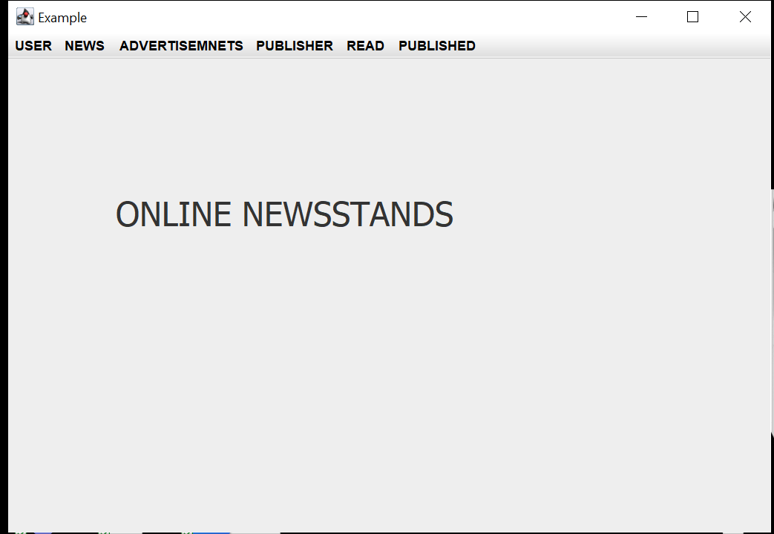

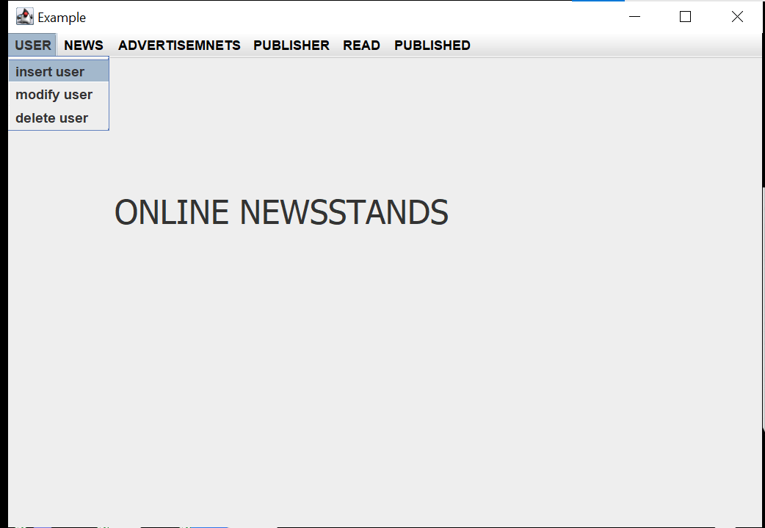

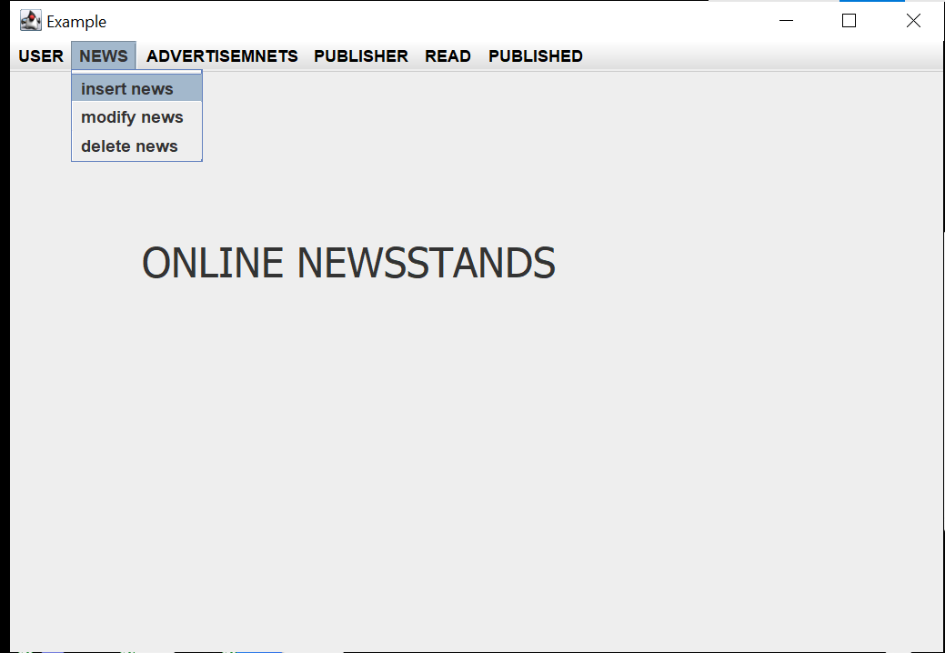

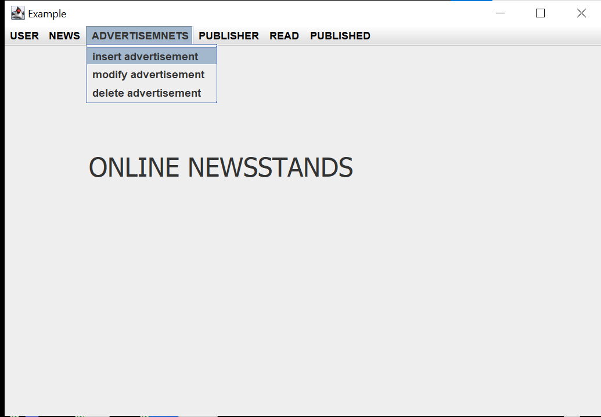

USER

